Access to Masters Offline Module

# MEd Tertiary and higher education

Use this worksheet to rate your abilities to find out if this Masters programme is suitable for you.

# Instructions

1. Graph 1 is the profile of a student who is suited to this subject.
2. Circle the statement that you feel best represents you on each of the 12 abilities below.
3. Plot your profile on Graph 2 and compare this with the suitable entry profile.
4. If your scores fall below the suitable entry profile, access the learning materials embedded in this document.
5. After working through the learning materials repeat steps 1 and 2 and compare your profile with the suitable entry profile.
6. If it is a match then you should apply for a place on the programme.

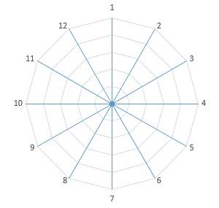

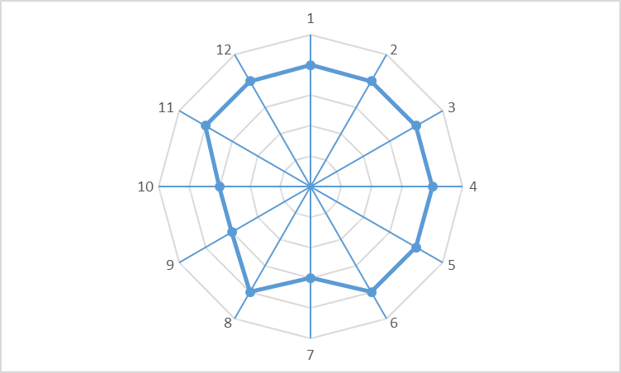

Suitable Profile

Your Profile

|  |  |  |
| --- | --- | --- |
| Ability 1 Referencing | | |
| How competent are you at referencing and citing resources? | **0** | I have no understanding of referencing |
| **1** | I am aware of the concept but have not used referencing |
| **2** | I have limited experience of referencing |
| **3** | I have used referencing, but not the UHI referencing system |
| **4** | I have used the UHI referencing system previously |
| **5** | I use the UHI referencing system regularly and am fully familiar with it |

|  |  |  |
| --- | --- | --- |
| Ability 2 Research cycle | | |
| When selecting and using robust academic sources…. | **0** | I have no understanding of the research cycle |
| **1** | I am aware of the research cycle but I have not engaged with it |
| **2** | I have engaged with the concept of the research cycle at undergraduate level but as part of a research project |
| **3** | I have engaged in very small scale research activity and understand the significance of research cycle |
| **4** | I have successfully engaged with undergraduate dissertation level research and the research cycle |
| **5** | I fully understand the research cycle and engage with it in ongoing my research activity |

|  |  |  |
| --- | --- | --- |
| Ability 3 Reading, analysing and synthesising | | |
| When reading analysing and synthesising source materials… | **0** | I have no concept of reflective professional practice |
| **1** | I have a limited understanding of reflective professional practice |
| **2** | I have no opportunity to reflect on my professional practice |
| **3** | I have read, but never written reflectively |
| **4** | I have written reflectively about my professional practice but I have not received any guidance or feedback on this |
| **5** | I write reflectively about my professional practice after having had guidance and feedback on it. |

|  |  |  |
| --- | --- | --- |
| Ability 4 Critical Analysis | | |
| My understanding of critical analysis is… | **0** | I have no understanding or experience of planning a teaching session |
| **1** | I have never planned a teaching session but I have some idea of how this might be done |
| **2** | I have some idea of how to plan a teaching session but have never enacted this |
| **3** | I have understand how to plan a teaching session and I have assisted others in planning a teaching session. |
| **4** | I have planned and delivered a limited number teaching sessions |
| **5** | I have planned and delivered multiple teaching sessions |

|  |  |  |
| --- | --- | --- |
| Ability 5 Researching | | |
| When researching to write my assignments… | **0** | I have a limited understanding of my own strengths and weaknesses and I have never analysed them. |
| **1** | I have a good understanding of my own strengths and weaknesses but I have never analysed then formally. |
| **2** | I am not aware of the SWOT framework. |
| **3** | I am aware of the SWOT framework but I have never used this to analyse my own strengths and weaknesses. |
| **4** | I am fully aware of my personal strengths and weaknesses and have used SWOT analysis to assess them. |
| **5** | I am fully aware of my personal strengths and weaknesses and have used SWOT analysis to assess them. |

|  |  |  |
| --- | --- | --- |
| Ability 6 Research Methods | | |
| When considering research and research methods, I… | **0** | I have no concept of subjectivity and objectivity |
| **1** | I have a limited understanding of subjectivity and objectivity |
| **2** | I am familiar with the terms subjectivity and objectivity |
| **3** | I understand the terms subjectivity and objectivity |
| **4** | I fully understand these terms |
| **5** | I am confident I can explain these terms to others |

|  |  |  |
| --- | --- | --- |
| Ability 7 Reading and Evaluating | | |
| When reading and evaluating published research … | **0** | I have no understanding of the term ‘netiquette’ |
| **1** | I have an idea of what this term might relate to |
| **2** | I understand the concept of netiquette but do not see the need to practice it |
| **3** | I practice netiquette but do not fully understand it |
| **4** | I understand the concept of netiquette and attempt to practice it most of the time |
| **5** | I fully understand and appreciate the need to practice netiquette at all times |

|  |  |  |
| --- | --- | --- |
| Ability 8 Research Cycle | | |
| When thinking about the research cycle… | **0** | I do not know how to assess the quality of academic evidence |
| **1** | I understand that there is a difference between academic and non-academic evidence but I not sure what it is |
| **2** | I recognise the difference between academic and non-academic evidence but I have never had to assess this in practice |
| **3** | I have had to assess the quality of academic evidence but only on the odd occasion |
| **4** | I have had to assess the quality of academic evidence at undergraduate level |
| **5** | I am fully aware and experienced in assessing the quality of academic evidence |

|  |  |  |
| --- | --- | --- |
| Ability 9 Online Environment | | |
| When working in an online environment… | **0** | I do not know how to read effectively |
| **1** | I understand that it is important to read effectively, but I have never been shown how to do this |
| **2** | I understand the concept of effective reading but have never had to do this |
| **3** | I am familiar with the concept of effective reading and have had to engage in this from time to time |
| **4** | I have read effectively at undergraduate level |
| **5** | I am experienced and competent at reading effectively. |

|  |  |  |
| --- | --- | --- |
| Ability 10 Communicative Action | | |
| Can you deliver and plan a session of learning and teaching? | **0** | I do not know what communicative action is |
| **1** | I am aware of this concept but have never engaged with it |
| **2** | I am aware of communicative action but I have no experience of engagement with it |
| **3** | I fully understand this concept but have not engaged with it |
| **4** | I am fully aware of communicative action and understand it but I have never engaged with it |
| **5** | I am fully aware of and understand the concept of communicative action and I practice this |

|  |  |  |
| --- | --- | --- |
| Ability 11 Assessing Student Learning | | |
| Can you assess students’ learning in your discipline? | **0** | I do not know how to assess student learning |
| **1** | I have some experience of assessing student learning through being a student myself |
| **2** | I have observed other assessing student learning |
| **3** | I have limited experience of assessing student learning myself |
| **4** | I have assessed student learning before but I have no formal training |
| **5** | I have formal training, knowledge and experience of assessing student learning |

|  |  |  |
| --- | --- | --- |
| Ability 12 Academic Writing | | |
| Can you develop high quality learning resources? | **0** | I have no experience of academic writing |
| **1** | I understand that academic writing is different from other forms of writing but I have never had to practice it |
| **2** | I understand the concept of academic writing but I have limited experience of doing it |
| **3** | I have written academically but not for quite some time |
| **4** | I have experience of writing academically at undergraduate level |
| **5** | I have plenty of competence and experience of writing academically |

|  |  |
| --- | --- |
| Here are the Learning resources for Access to MEd Tertiary & Higher Education, use these to enhance your ability to be successful on this master’s programme. |  |